# **Foundation**

## **1. System Architecture**

### **Overview:**

The system architecture is designed to provide a seamless shopping experience while maintaining flexibility and scalability. The major components include:

* **Frontend (Next.js)**: Handles UI and client-side interactions.
* **Sanity CMS**: Stores and manages product data, order details, and customer information.
* **Deployment (Vercel)**: Manages hosting and continuous integration.

### **High-Level Diagram:**

[Frontend (Next.js)]

| | |

[Sanity CMS] [Stripe API] [Future: Shipping API]

| |

[Product Data] [Payment Processing]

## **2. Key Workflows**

### **User Registration:**

* A new user signs up.
* Data is stored in Sanity CMS.
* Confirmation is sent to the user.

### **Product Browsing:**

* User visits the homepage and views available furniture.
* Data is fetched from Sanity CMS and displayed.
* Filters and search functionality improve the browsing experience.

### **Order Placement:**

* User adds items to the cart.
* Proceeds to checkout and submits order.
* Order details are stored in Sanity CMS.

## **3. API Endpoints**

### **Product API:**

* **Endpoint:** /api/products
* **Method:** GET
* **Description:** Fetches all product details.
* **Response Example:**

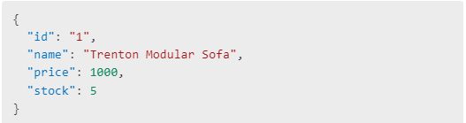

### **Order API:**

* **Endpoint:** /api/orders
* **Method:** POST
* **Description:** Creates a new order in Sanity CMS.
* **Payload Example:**

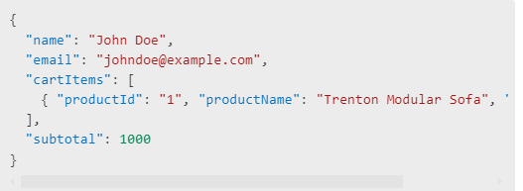

Product scheme

export default

name: 'product',

title: 'Product',

type: 'document',

fields: [

{ name: 'id', type: 'string', title: 'ID' },

{ name: 'name', type: 'string', title: 'Name' },

{ name: 'imagePath', type: 'url', title: 'Image Path' },

{ name: 'price', type: 'number', title: 'Price' },

{ name: 'description', type: 'text', title: 'Description' },

{ name: 'discountPercentage', type: 'number', title: 'Discount Percentage' },

{ name: 'isFeaturedProduct', type: 'boolean', title: 'Is Featured Product' },

{ name: 'stockLevel', type: 'number', title: 'Stock Level' },

{ name: 'category', type: 'string', title: 'Category' },

],

};

Order scheme

export default {

name: 'order',

title: 'Order',

type: 'document',

fields: [

{ name: 'name', type: 'string', title: 'Customer Name' },

{ name: 'email', type: 'string', title: 'Email' },

{ name: 'address', type: 'text', title: 'Address' },

{ name: 'city', type: 'string', title: 'City' },

{ name: 'postalCode', type: 'string', title: 'Postal Code' },

{ name: 'country', type: 'string', title: 'Country' },

{ name: 'phoneNumber', type: 'string', title: 'Phone Number' },

{ name: 'cartItems', type: 'array', of: [{ type: 'object', fields: [

{ name: 'productId', type: 'string', title: 'Product ID' },

{ name: 'productName', type: 'string', title: 'Product Name' },

{ name: 'quantity', type: 'number', title: 'Quantity' },

]}]},

{ name: 'subtotal', type: 'number', title: 'Subtotal' },

],

};